

Students Name:………………………………………

SPECIALIST MATHEMATICS

TRIAL EXAMINATION 2

(ANALYSIS TASK)

2004

Reading Time: 15 minutes
Writing time: 90 minutes

Instructions to students
This exam consists of 5 questions.
All questions should be answered.
There is a total of 60 marks available.
The marks allocated to each of the five questions are indicated throughout.
Students may bring up to two A4 pages of pre-written notes into the exam.
The acceleration due to gravity should be taken to have magnitude 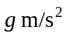where 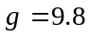
Formula sheets can be found on pages 15-17 of this exam.
Diagrams in this exam are not to scale except where otherwise stated.

This paper has been prepared independently of the Victorian Curriculum and Assessment Authority to provide additional exam preparation for students. Although references have been reproduced with permission of the Victorian Curriculum and Assessment Authority, the publication is in no way connected with or endorsed by the Victorian Curriculum and Assessment Authority.

© THE HEFFERNAN GROUP 2004
This Trial Exam is licensed on a non transferable basis to the purchaser. It may be copied for educational use within the school which has purchased it. This license does not permit distribution or copying of this Trial Exam outside that school or by any individual purchaser.
Question 1

A crane is mounted on the back of a truck. It has an arm that can be retracted or extended.

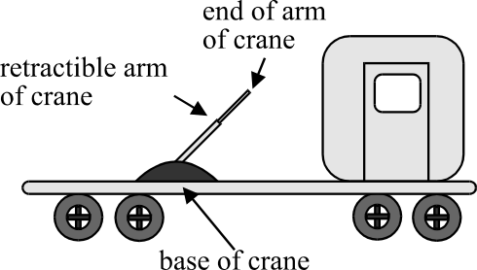

The arm of the crane can be rotated in such a way that the points in space that can be reached by the end of the arm of the crane form a solid in the shape of an inverted cone with a curved top, as shown in the diagram below.
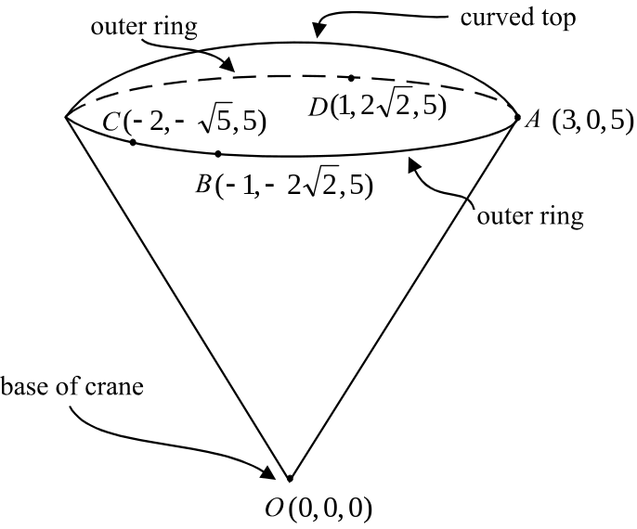

Point O corresponds to the base of the crane. Let 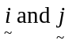 be unit vectors in the direction of the right hand side and front end respectively of the truck. Let be a unit vector in the vertically upwards direction. Points A, B, C and D lie on the edge of the outer ring of the solid.
The coordinates of the points in and on the solid shape are given in relation to point O and the unit is metres.

- What is the highest point vertically above the base of the crane that the crane can reach when inclined at its maximum angle from the vertical?
Explain your answer.

2 marks
b. What is the length of the arm of the crane when fully extended?

1 mark

c. i. Find 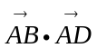.

2 marks

  - By using your result from part i. and by finding the scalar product of two other vectors, confirm that the points A, B, C and D lie on a circle.

3 marks
d. At a particular time, the end of the arm of the crane is located at D.
Find the angle that the arm of the crane must turn through from there so that the end of the crane is located at the point 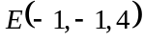. Express your answer to the nearest minute.

3 marks
Total 11 marks

Question 2

Let 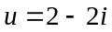.

- i. Find 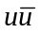.

1 mark

  - Find 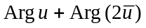.

1 mark

- i. Show that u is a solution of the equation

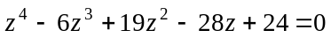

______________________________________________________________
1 mark

  - Hence find the other three solutions of this equation.

3 marks

- Let 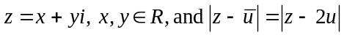

By graphing or otherwise find the value of x when 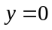.

2 marks

- Using De Moivre’s theorem, find all the values of n, such that

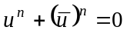

4 marks
Total 12 marks

Question 3

Consider the function

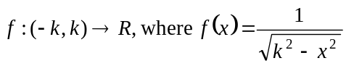 and k is a positive constant.

a. i. On the set of axes below, sketch the graph of 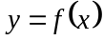, labelling clearly any
key features.
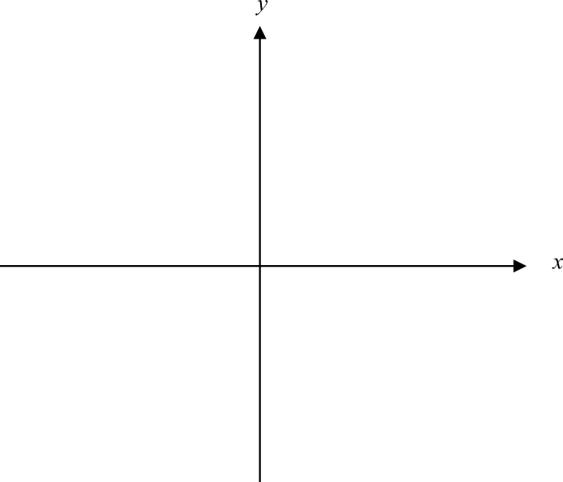

2 marks

  - Write down the range of f.

1 mark

- Find the area enclosed by the graph of , the positive x and y axes and the line with equation 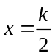.

______________________________________________________________

______________________________________________________________

______________________________________________________________
2 marks

c. The region bounded by the graph of 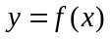, the y-axis and the line 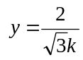 is
rotated around the y-axis to form a solid of revolution.

Find the volume of this solid of revolution. Express your answer as an exact value.

5 marks
Total 10 marks

Question 4

In an underground mine, a pump operates continuously to pump out 50 litres of water each hour.

On a particular day, after a malfunction in the pump, the rate at which the pump could pump water was given by

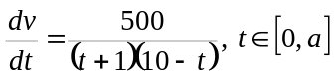

where 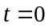 corresponded to that time when the pump began to malfunction. The time when the repair team repaired the pump and had it pumping again at 50 litres per hour is described by 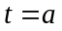 hours.

- What is the value of a?

1 mark

- Use calculus to find the minimum rate, in litres per hour, at which the pump was pumping during the period when it was malfunctioning.
Express your answer correct to 2 decimal places and verify that it is a minimum value.

4 marks
- Find an antiderivative of 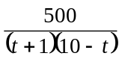.

3 marks

- Show that the volume of water, in litres, that the malfunctioning pump had pumped t hours after the malfunction began is given by

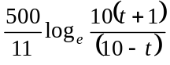

2 marks

- Two hours after the pump had begun to malfunction, how many extra litres of water were in the mine that would normally not have been there had the pump been operating properly? Express your answer correct to 2 decimal places.

2 marks

- This mine can only cope with an additional 250 litres of water over what is normally present when the pump is operating properly. Using your graphics calculator, find whether this limit is exceeded during the period when the pump was malfunctioning.

3 marks
Total 15 marks

Question 5

On a production line lollies slide individually down a metal chute before dropping onto a conveyor belt which is 0.4m vertically below the end of the metal chute.
The metal chute which is 2 m long, is on an angle of 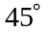 with the horizontal as shown in the diagram below.
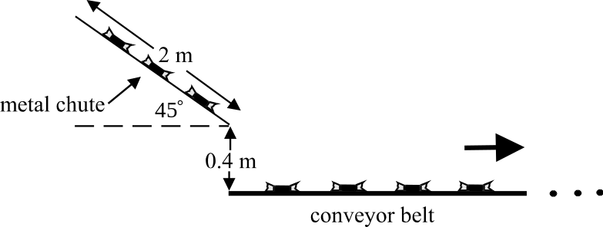

The coefficient of friction between a lolly and the metal chute is 0.5.
The forces acting on a lolly, (each of which have a mass of 0.025kg) as it slides down the metal chute are the weight force, the normal reaction and the friction force.

- On the diagram below, show the forces acting on a lolly.

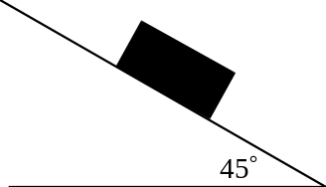

1 mark

- Show that a lolly would slide down the metal chute with an acceleration of 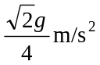.

3 marks
c. Given that a lolly is moving at 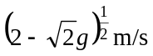 at the top of the metal chute, show that
the speed at which the lolly is moving at the end of the metal chute is 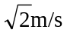.

2 marks

d. Assuming that there are no resistance forces and that is directed upwards and points from left to right, explain why the velocity vector for a lolly after it has dropped off the end of the metal chute is given by

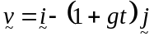.

3 marks

e. Find the horizontal distance from the bottom end of the metal chute to the point where the lolly would land.
Express your answer correct to 1 decimal place.

3 marks
Total 12 marks

Specialist Mathematics Formulas

Mensuration
area of a trapezium: 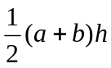
curved surface area of a cylinder: 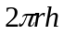
volume of a cylinder: 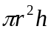
volume of a cone: 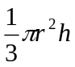
volume of a pyramid: 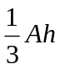
volume of a sphere: 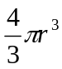
area of a triangle: 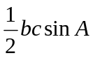
sine rule: 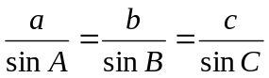
cosine rule: 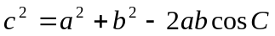

Coordinate geometry
ellipse: 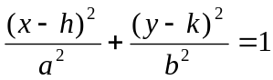
hyperbola: 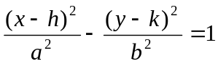

Circular (trigonometric) functions
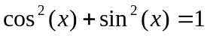
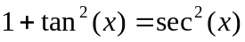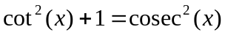
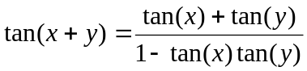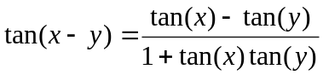
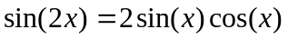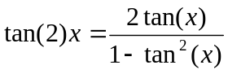
function | 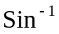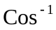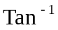
domain  range | 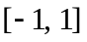  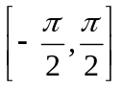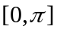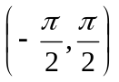
Reproduced with permission of the Victorian Curriculum and Assessment Authority, Victoria, Australia.
These formula sheets have been copied from the 2003 Specialist Maths Exam 2. Teachers and students are reminded that changes to formula sheets are notified in the VCE Bulletins and on the VCAA website.at www.vcaa.vic.edu.au
The VCAA publish an exam issue supplement to the VCAA Bulletin.
Algebra (Complex numbers)

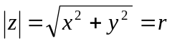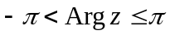
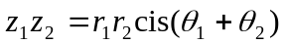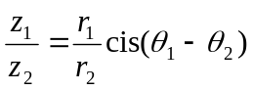
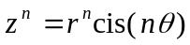 (de Moivre’s theorem)

Calculus

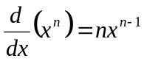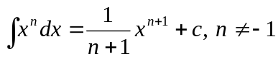
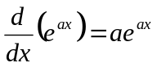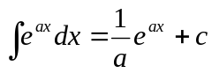
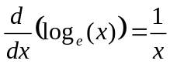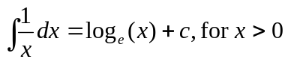
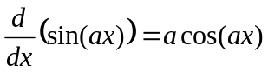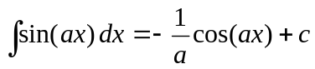
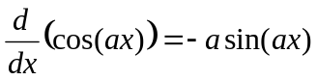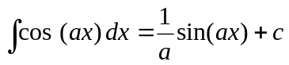
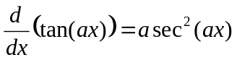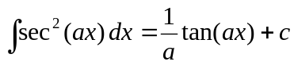
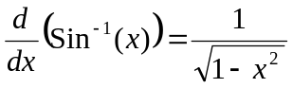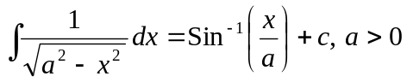
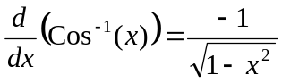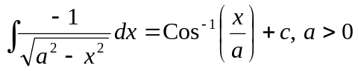
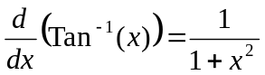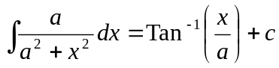

product rule: 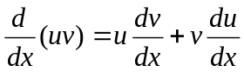
quotient rule: 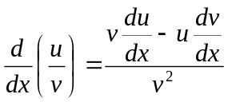
chain rule: 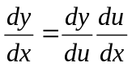

Reproduced with permission of the Victorian Curriculum and Assessment Authority, Victoria, Australia.
These formula sheets have been copied from the 2003 Specialist Maths Exam 2. Teachers and students are reminded that changes to formula sheets are notified in the VCE Bulletins and on the VCAA website.at www.vcaa.vic.edu.au
The VCAA publish an exam issue supplement to the VCAA Bulletin.
mid-point rule: 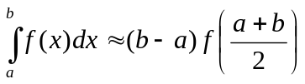
trapezoidal rule: 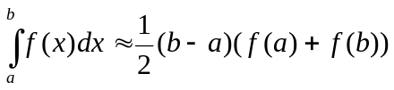
Euler’s method: 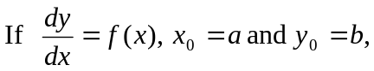
acceleration: 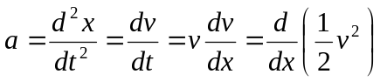
constant (uniform) acceleration: 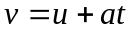 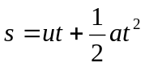 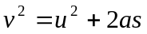 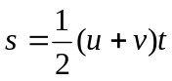

Vectors in two and three dimensions

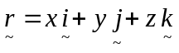
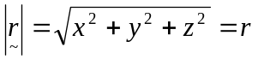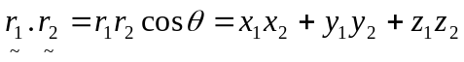
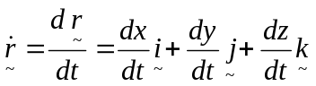

Mechanics

momentum: 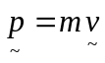
equation of motion: 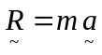
friction: 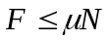

Reproduced with permission of the Victorian Curriculum and Assessment Authority, Victoria, Australia.
These formula sheets have been copied from the 2003 Specialist Maths Exam 2. Teachers and students are reminded that changes to formula sheets are notified in the VCE Bulletins and on the VCAA website.at www.vcaa.vic.edu.au
The VCAA publish an exam issue supplement to the VCAA Bulletin.

